Nested Table

# Program 1:

<!DOCTYPE html>

<html lang="en">

  <head>

    <meta charset="UTF-8" />

    <meta name="viewport" content="width=device-width, initial-scale=1.0" />

    <title>Document</title>

  </head>

  <body>

    <table border="10px" width="350px" height="300px" bordercolor="red">

      <tr>

        <td>

          <table border="1px" bordercolor="yellow">

            <tr>

              <td colspan="2">Nested Table 1</td>

            </tr>

            <tr>

              <td>Column 1</td>

              <td>Column 2</td>

            </tr>

            <tr>

              <td>Our first table</td>

              <td>Nested within</td>

            </tr>

          </table>

        </td>

        <td>

          <table border="1px" bordercolor="blue" width="150px">

            <tr>

              <td>Nested Table 2</td>

            </tr>

            <tr>

              <td>

                <ul>

                  <li>list object 1</li>

                  <li>list object 2</li>

                  <li>list object 3</li>

                </ul>

              </td>

            </tr>

          </table>

        </td>

      </tr>

      <tr>

        <td>

          <table border="1px" bordercolor="green">

            <tr>

              <th colspan="2">Nested Table 3</th>

            </tr>

            <tr>

              <td>Nested table</td>

              <td>Demo continued</td>

            </tr>

          </table>

        </td>

        <td>

          <table border="1px" bordercolor="royalblue">

            <tr>

              <td>Nested Table 4</td>

            </tr>

            <tr>

              <td>

                <img src="imgs/dvd.jpg" alt="" width="50" align="center" />

              </td>

            </tr>

          </table>

        </td>

      </tr>

    </table>

  </body>

</html>

# OutPut :

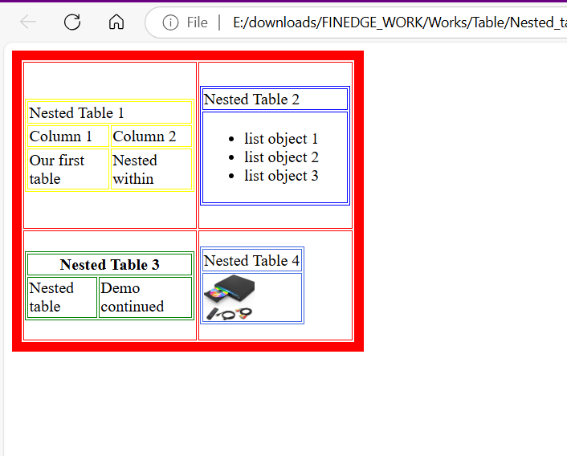

# Program 2 :

<!DOCTYPE html>

<html lang="en">

<head>

    <meta charset="UTF-8">

    <meta name="viewport" content="width=device-width, initial-scale=1.0">

    <title>Document</title>

</head>

<body><center>

    <table bgcolor="green" width="400px" height="200px">

        <tr>

            <td><p>camera, in photography, device for recording an image of an object on a light-sensitive surface; it is essentially a light-tight box with an aperture to admit light focused onto a sensitized film or plate. 35mm single-lens reflex (SLR)</p></td>

            <td><img src="imgs/camera.jfif" alt=""></td>

        </tr>

    </table>

</center>

</body>

</html>

# OutPut :

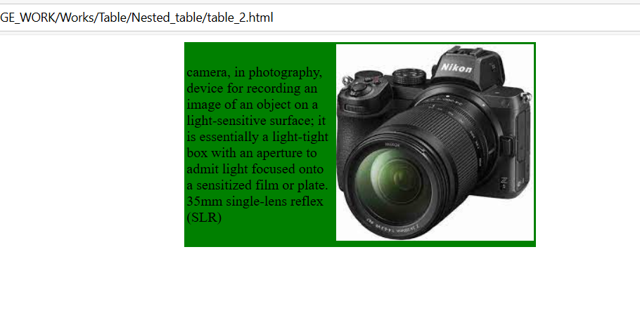

# Program 3 :

<!DOCTYPE html>

<html lang="en">

  <head>

    <meta charset="UTF-8" />

    <meta name="viewport" content="width=device-width, initial-scale=1.0" />

    <title>Document</title>

  </head>

  <body bgcolor="yellow">

    <h1 align="center">BABY PRODUCTS</h1>

    <table align="center">

      <tr>

        <td>

          <img src="imgs/main_jh.jfif" alt="" width="500px" height="640px" />

        </td>

        <td>

          <table width="620px">

            <tr>

              <td>

                <img

                  src="imgs/jhonson1.jpeg"

                  alt=""

                  width="150px"

                  height="200px"

                />

              </td>

              <td>

                ABOUT : <br />

                <p>

                  Baby powder is a talcum powder used to prevent diaper rash, as

                  a deodorant, and for other cosmetic uses. It is typically made

                  from talc, a mineral that is composed of magnesium, silicon,

                  and oxygen When using baby powder, it's important to apply it

                  carefully to avoid inhalation. Shake a small amount of powder

                  into your hand and then apply it to the desired area, gently

                  rubbing it into the skin. There have been concerns about the

                  safety of talcum powder due to its potential link to ovarian

                  cancer and respiratory issues. Inhaling talcum powder can

                  cause respiratory problems, especially in infants

                </p>

              </td>

            </tr>

            <tr>

              <td>

                <img

                  src="imgs/jhoneson2.jpg"

                  alt=""

                  width="150px"

                  height="200px"

                />

              </td>

              <td>

                ABOUT : <br />

                <p>

                  Baby powder is a talcum powder used to prevent diaper rash, as

                  a deodorant, and for other cosmetic uses. It is typically made

                  from talc, a mineral that is composed of magnesium, silicon,

                  and oxygen When using baby powder, it's important to apply it

                  carefully to avoid inhalation. Shake a small amount of powder

                  into your hand and then apply it to the desired area, gently

                  rubbing it into the skin. There have been concerns about the

                  safety of talcum powder due to its potential link to ovarian

                  cancer and respiratory issues. Inhaling talcum powder can

                  cause respiratory problems, especially in infants

                </p>

              </td>

            </tr>

            <tr>

              <td>

                <img

                  src="imgs/jhonenson3.webp"

                  alt=""

                  width="150px"

                  height="200px"

                />

              </td>

              <td>

                ABOUT : <br />

                <p>

                  Baby powder is a talcum powder used to prevent diaper rash, as

                  a deodorant, and for other cosmetic uses. It is typically made

                  from talc, a mineral that is composed of magnesium, silicon,

                  and oxygen When using baby powder, it's important to apply it

                  carefully to avoid inhalation. Shake a small amount of powder

                  into your hand and then apply it to the desired area, gently

                  rubbing it into the skin. There have been concerns about the

                  safety of talcum powder due to its potential link to ovarian

                  cancer and respiratory issues. Inhaling talcum powder can

                  cause respiratory problems, especially in infants

                </p>

              </td>

            </tr>

          </table>

        </td>

      </tr>

    </table>

</body>

</html>

# OutPut :

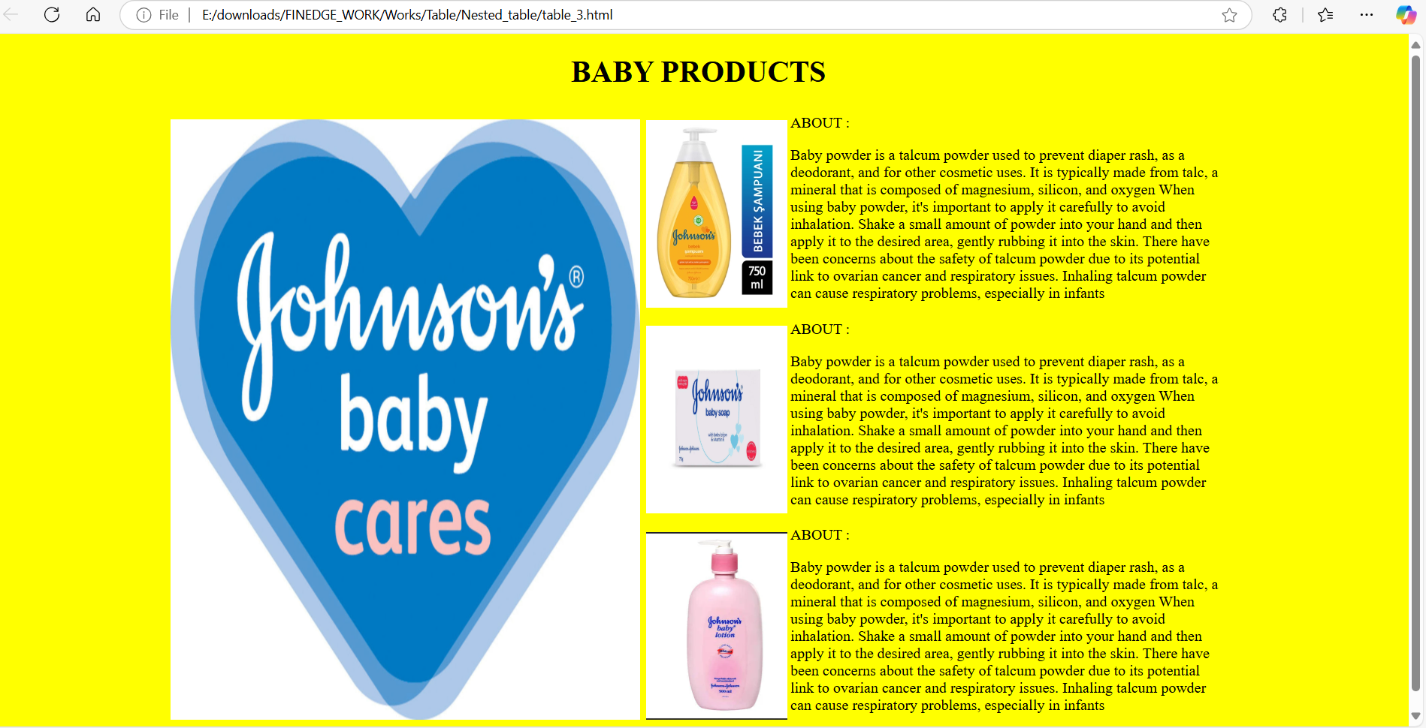

# Program 4 :

<!DOCTYPE html>

<html lang="en">

  <head>

    <meta charset="UTF-8" />

    <meta name="viewport" content="width=device-width, initial-scale=1.0" />

    <title>Document</title>

  </head>

  <body>

    <table border="1px" align="center" width="400px" height="200px">

      <tr align="center">

        <td rowspan="2" colspan="2">CI</td>

        <td rowspan="2">All Genders</td>

        <td>By Gender</td>

      </tr>

      <tr align="center">

        <td>

          <table border="1px">

            <tr>

              <th>Male</th>

              <th>Females</th>

            </tr>

            <tr>

              <th>9215604</th>

              <th>4512358</th>

            </tr>

          </table>

        </td>

      </tr>

      <tr align="center">

        <td>Rural</td>

        <td>1245781</td>

        <td>4578465</td>

        <td>7896541</td>

      </tr>

    </table>

  </body>

</html>

# OutPut :

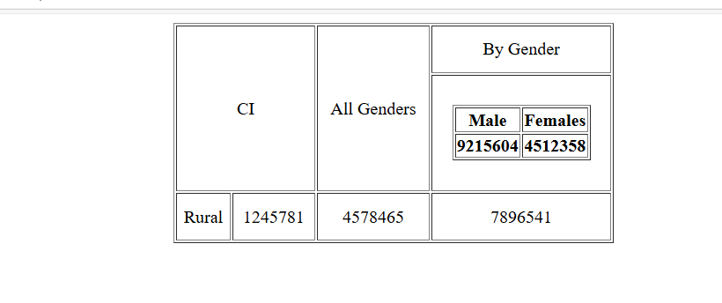

# Program 5:

<!DOCTYPE html>

<html lang="en">

  <head>

    <title>Document</title>

  </head>

  <body>

    <table bgcolor="green" align="center" width="300px" height="300px">

      <tr align="center">

        <td>

          <table bgcolor="white">

            <tr>

              <th height="30px" width="100px">Days</th>

            </tr>

          </table>

        </td>

        <td>

          <table bgcolor="white">

            <tr>

              <th height="30px" width="100px">Weather</th>

            </tr>

          </table>

        </td>

      </tr>

      <tr align="center">

        <td>

          <table bgcolor="white">

            <tr>

              <th height="30px" width="100px">Monday</th>

            </tr>

          </table>

        </td>

        <td>

          <table bgcolor="white">

            <tr>

              <th height="30px" width="100px">Sunny</th>

            </tr>

          </table>

        </td>

      </tr>

      <tr align="center">

        <td>

          <table bgcolor="white">

            <tr>

              <th height="30px" width="100px">Tuesday</th>

            </tr>

          </table>

        </td>

        <td>

          <table bgcolor="white">

            <tr>

              <th height="30px" width="100px">Rainy</th>

            </tr>

          </table>

        </td>

      </tr>

    </table>

  </body>

</html>

# OutPut :

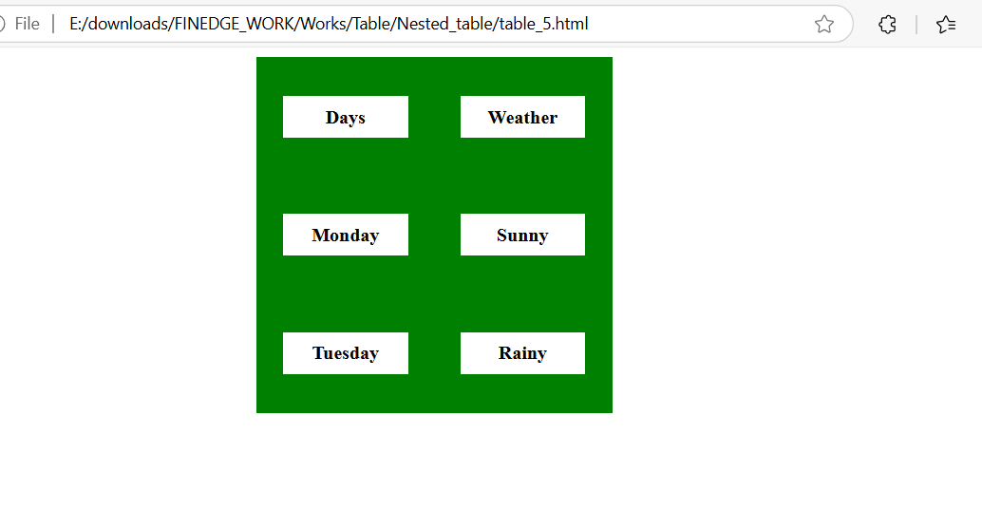

# Program 6:

<!DOCTYPE html>

<html lang="en">

  <head>

    <meta charset="UTF-8" />

    <meta name="viewport" content="width=device-width, initial-scale=1.0" />

    <title>Document</title>

  </head>

  <body>

    <table border="1px">

      <tr>

        <th>Product Name</th>

        <th>Price List</th>

        <th>Count</th>

      </tr>

      <tr>

        <td>

          <ul type="square">

            <li>classmate books</li>

            <li>instrument box</li>

            <li>pencil kit</li>

            <li>school bag</li>

          </ul>

        </td>

        <td>

          <ol>

            <li>$ 450</li>

            <li>$ 12</li>

            <li>$ 6</li>

            <li>$ 300</li>

          </ol>

        </td>

        <td>

          <ol type="I">

            <li>5</li>

            <li>12</li>

            <li>18</li>

            <li>5</li>

          </ol>

        </td>

      </tr>

    </table>

  </body>

</html>

# OutPut :

